Raymond Delgado

Professor Woo

CIS 5560

April 12, 2020

Zeppelin

Python_Pipeline:

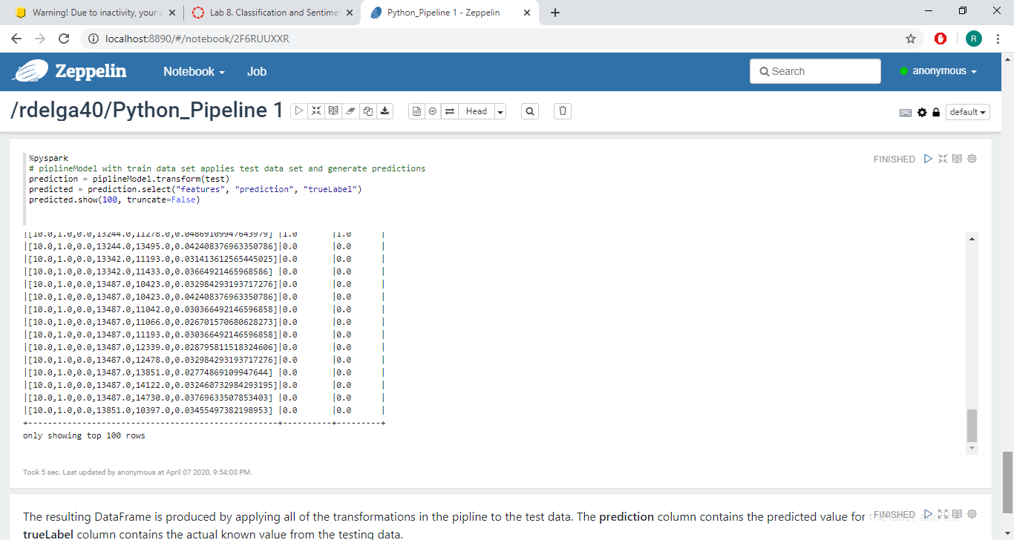

Databrick:

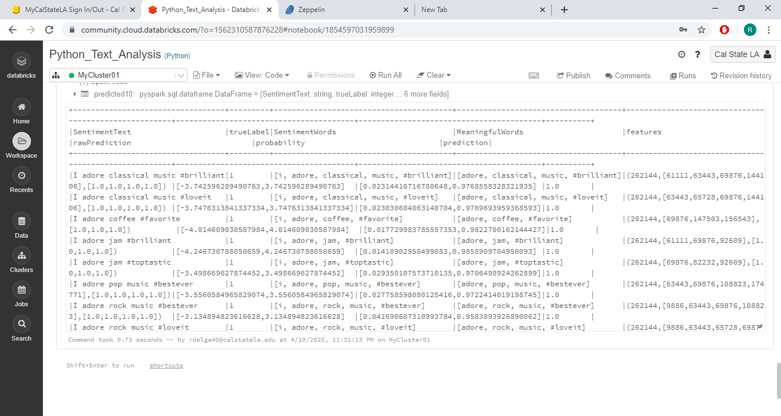

Python Command Line Interface:

Python Pipeline Databricks

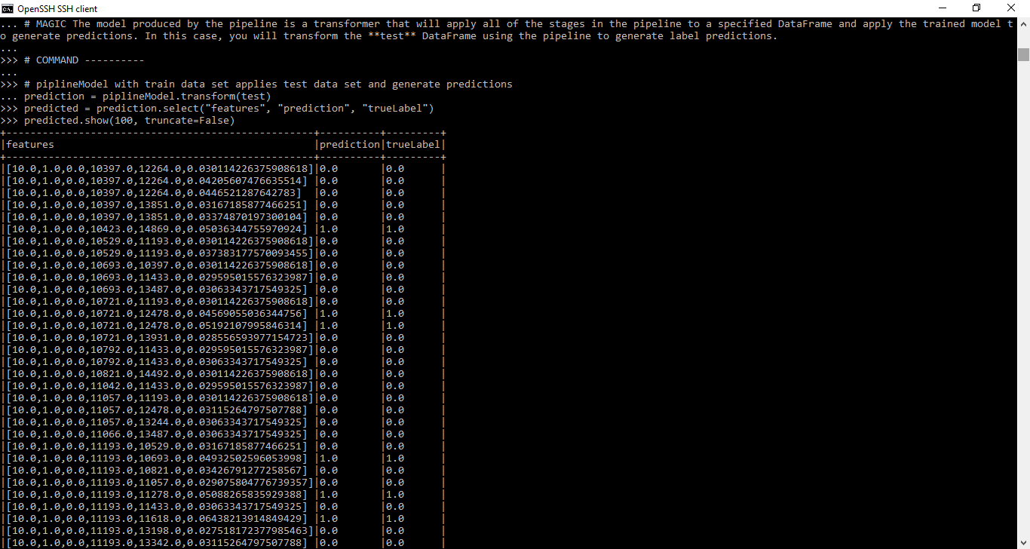

Python Text Analysis:

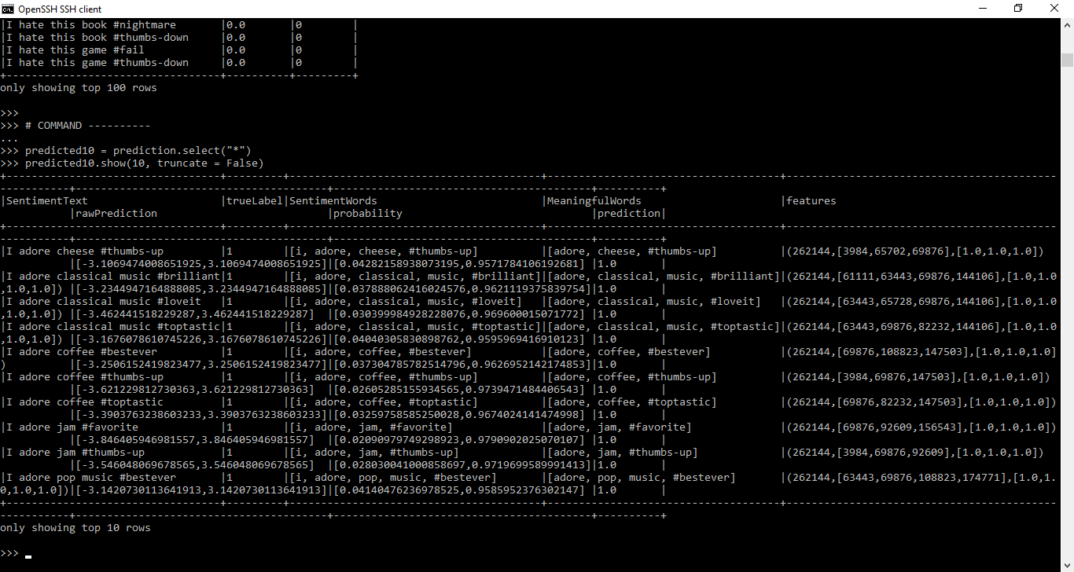

Zeppelin Text Analysis:

